Software Design Document (SDD)
Module: Timer Driver
STM32F4xx — Microcontrollers and Embedded Systems, CETYS Universidad
Module | TIM (Hardware Timer) Driver
Version | 1.0
Authors | David Mijares, Aldo de la Torre, Jose Paez
Platform | STM32F4xx
Clock | 16 MHz (HSI)
Course | Microcontrollers and Embedded Systems — CETYS Universidad

1. Introduction

1.1. Purpose
The purpose of the Timer Driver is to provide a simple and reliable interface for generating accurate blocking delays using STM32 hardware timers. The module abstracts the underlying TIM peripheral configuration and operation, allowing application code to create millisecond-based delays without relying on software delay loops. By leveraging hardware timer resources and polling-based completion detection, the driver improves timing accuracy, enhances portability, and simplifies time-dependent operations within embedded applications running on STM32 microcontrollers.

1.2. Scope
The Timer Driver is a low-level software component designed for embedded real-time applications running on STM32 microcontrollers. It provides a simple abstraction layer over the underlying TIM driver, enabling application modules to generate accurate time delays without directly interacting with hardware timer registers. The driver uses hardware timer resources in polling mode to implement blocking delays with millisecond resolution, ensuring greater timing accuracy than software-based delay loops. The module allows higher-level software components to:
- Initialize and configure hardware timers for delay generation.
- Generate blocking delays with user-defined durations in milliseconds.
- Utilize hardware timer counting mechanisms instead of CPU-intensive software loops.
- Simplify timing-related operations through a lightweight and easy-to-use API.
- Provide a reusable delay service for application modules requiring deterministic wait periods.

1.3. Definitions and Acronyms
Term | Definition
Timer Driver | Software module that provides an abstraction layer for generating hardware timer-based delays.
TIM | STM32 hardware timer peripheral used as the timing source for delay generation.
TIM Driver | Lower-level driver responsible for configuring and controlling STM32 timer peripherals.
timer_init() | API function used to initialize the timer module and configure the selected timer instance for delay generation.
timer_delay_ms() | API function that generates a blocking delay for a specified number of milliseconds.
tim_t | Enumeration type representing a logical timer instance managed by the TIM driver.
Blocking Delay | Delay mechanism that halts program execution until the specified delay period has elapsed.
Polling Mode | Operating mode in which software continuously checks the timer status until the delay is complete.
Millisecond (ms) | Unit of time equal to one thousandth of a second, used as the delay resolution provided by the module.
Timer Counter | Internal hardware register that increments or decrements according to the timer clock source.
Timer Period | Configured duration after which the timer reaches its terminal count and generates an update event.
Update Event | Hardware timer event generated when the counter reaches the configured period value.
Hardware Delay | Delay generated using a dedicated timer peripheral instead of software execution loops.

2. System Architecture

2.1. High-Level Design
The Timer Driver follows a simple layered architecture that separates application-level delay requests from the underlying hardware timer implementation:

- Application Layer — User code invokes the Timer Driver public API functions (e.g., timer_init() and timer_delay_ms()) to generate delays without requiring knowledge of timer configuration details, hardware registers, or clock settings.
- Timer Driver Layer — Implements the delay generation functionality. This layer initializes the selected timer instance, configures the desired delay duration, starts and stops the timer, and manages the polling-based wait mechanism. It serves as an abstraction layer between the application and the low-level TIM driver.
- TIM Driver Layer / Hardware Abstraction Layer — Provides direct access to the STM32 timer peripherals through functions such as tim_initTimer(), tim_setTimerMs(), tim_enableTimer(), tim_waitTimer(), and tim_disableTimer(). This layer handles timer register configuration and timer operation.
- Hardware Layer — Consists of the STM32 hardware timer peripherals (TIM1, TIM2, TIM3, TIM4, TIM5, TIM9, TIM10, TIM11, or any supported timer instance) used to generate accurate timing intervals. The timer hardware performs the actual counting operation and generates the timing events required to implement millisecond delays.

2.2. Module Interfaces
- Public API — All externally callable functions are declared in Timer.h and implemented in Timer.c. The module exposes a simple interface consisting of timer_init() for timer initialization and timer_delay_ms() for generating blocking delays with millisecond resolution.
- Dependencies — The driver depends on TIM.h for access to the low-level timer driver services and timer type definitions (tim_t). It also depends on stdint.h for fixed-width integer types and includes GPIO.h as part of the module interface. The implementation relies on the TIM driver functions (tim_init(), tim_initTimer(), tim_setTimerMs(), tim_enableTimer(), tim_waitTimer(), and tim_disableTimer()) to control the underlying hardware timer peripheral.
- Inter-Driver Dependencies — The Timer Driver acts as a wrapper around the TIM driver and directly invokes TIM driver APIs to configure and operate hardware timers. The module does not directly access timer registers and does not implement timer functionality independently. No direct interaction with GPIO peripherals is performed by the driver implementation.

3. Detailed Design

3.1. Class Diagram
The diagram below shows the static structure of the Timer module and its relationships with the CMSIS hardware abstractions.

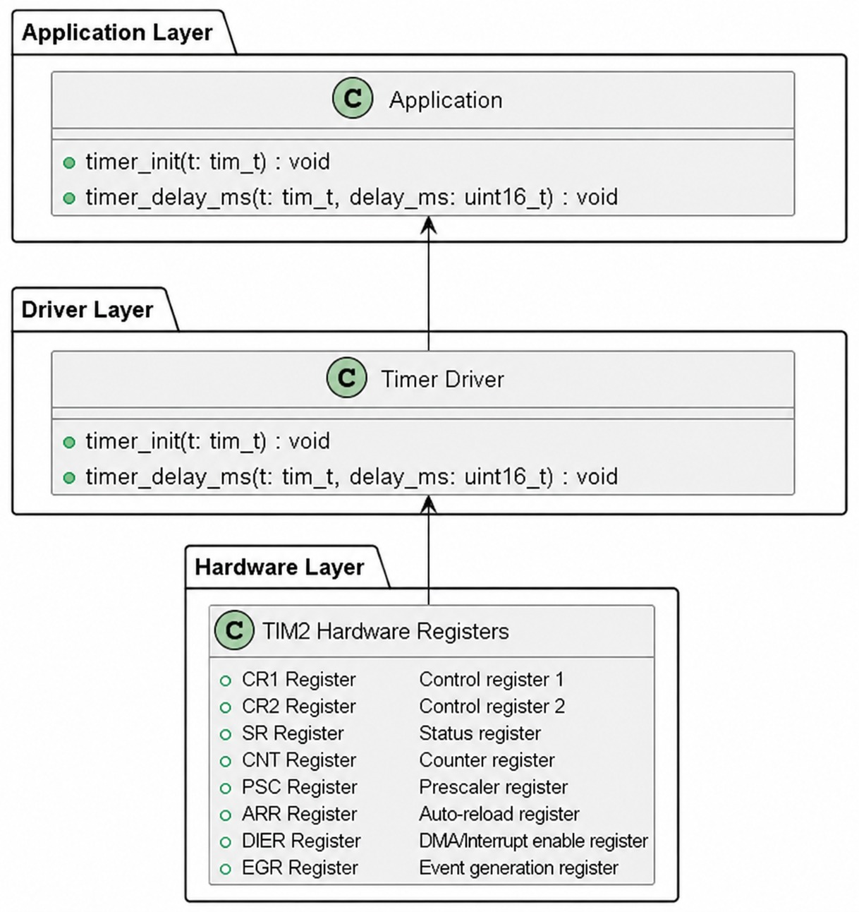
Figure 1. Class Diagram – Timer Driver

3.2. Module Behavior
The following diagrams capture the dynamic behavior of the most relevant driver operations. Sequence diagrams show the interaction between actors and objects over time; activity diagrams show the internal control flow of individual functions.
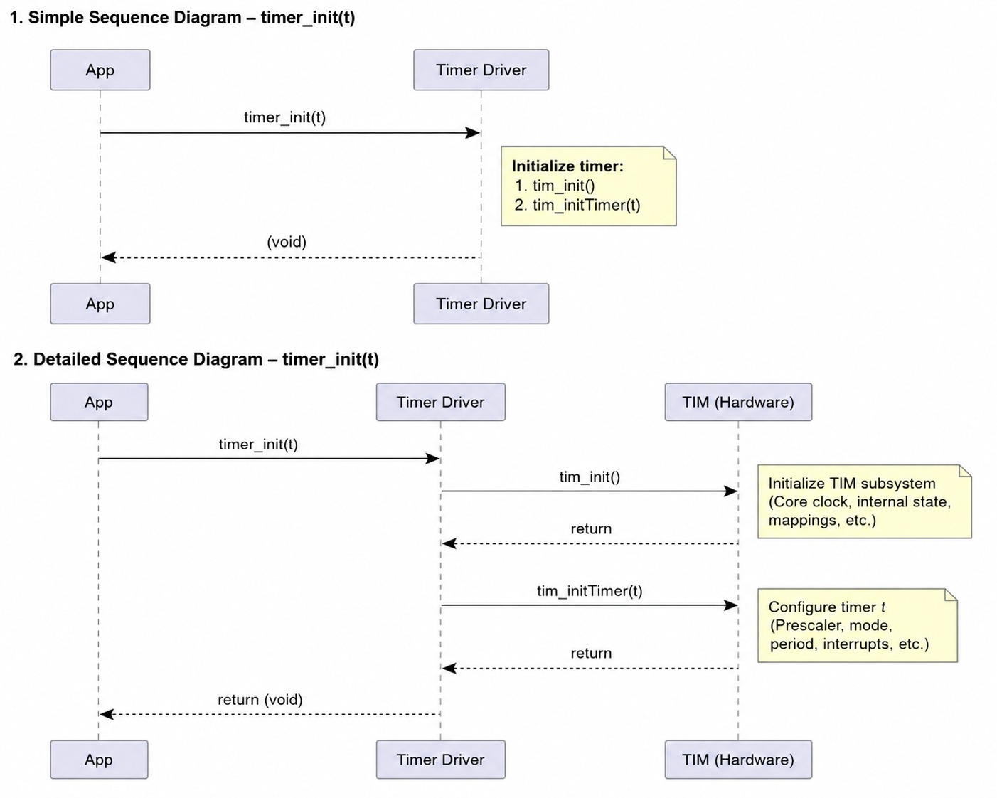
Figure 2. timer_init diagrams
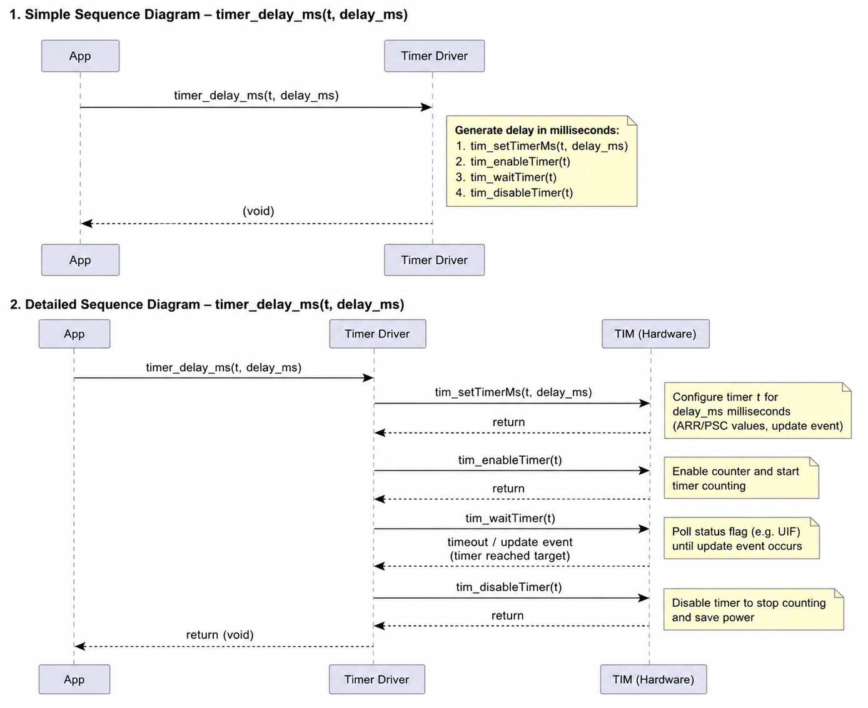
Figure 3. Timer_delay_ms Diagrams

3.3. Timer Driver — Design Notes
Key design decisions and implementation details developers must be aware of:
- Hardware timer abstraction — The module does not directly access timer registers. All timer configuration and control operations are delegated to the underlying TIM driver through functions such as tim_initTimer(), tim_setTimerMs(), tim_enableTimer(), tim_waitTimer(), and tim_disableTimer().
- Initialization requirement — timer_init() must be called before any call to timer_delay_ms(). This function initializes the TIM driver and configures the selected timer instance for delay generation.
- Blocking operation — The timer_delay_ms() function implements a blocking delay. Program execution is suspended until the configured timer interval expires and the timer completion condition is detected by the TIM driver.
- Hardware-based timing — Delay generation relies on dedicated STM32 timer peripherals rather than software delay loops. This approach provides improved timing accuracy and reduces dependency on CPU execution speed.
- Timer lifecycle management — Each delay operation follows a fixed sequence: configure the delay period, enable the timer, wait for timer completion, and disable the timer. This ensures predictable timer behavior and avoids unnecessary timer activity after the delay has elapsed.
- Polling-based synchronization — The driver uses polling through tim_waitTimer() to detect timer completion. No interrupt-based delay mechanism is implemented in this module.
- Timer instance flexibility — The driver supports any timer instance represented by the tim_t type. The specific hardware timer used depends on the timer selected during initialization.
- No error reporting mechanism — The API functions do not return status or error codes. Failures occurring in the underlying TIM driver cannot be detected directly through the Timer Driver interface.
- No parameter validation — The module assumes that the provided timer identifier (tim_t) is valid and that the underlying TIM driver has been properly initialized.
- Re-entrancy — The driver is not designed to be re-entrant. Concurrent access to the same timer instance from multiple tasks, threads, or interrupt service routines may produce undefined behavior.
- Interrupt usage restriction — Because delays are implemented as blocking operations, timer_delay_ms() should not be called from interrupt service routines where deterministic interrupt latency is required.
- Dependency on TIM driver configuration — Delay accuracy depends on the correct clock configuration, prescaler settings, and timer implementation provided by the underlying TIM driver. Any changes to the TIM driver may affect the behavior of this module.

4. Application Programming Interfaces

4.1. Data Types and Macros
tim_t - tim_t is an enumeration type defined by the underlying TIM driver that represents a logical timer instance. It is used by the Timer Driver APIs to identify the hardware timer that will be configured and used for delay generation.
Member Name | Value | Notes / Definition
TIM_1 | Implementation-defined | Logical identifier corresponding to Timer 1.
TIM_2 | Implementation-defined | Logical identifier corresponding to Timer 2. Commonly used for delay generation.
TIM_3 | Implementation-defined | Logical identifier corresponding to Timer 3.
TIM_4 | Implementation-defined | Logical identifier corresponding to Timer 4.
TIM_5 | Implementation-defined | Logical identifier corresponding to Timer 5.
TIM_9 | Implementation-defined | Logical identifier corresponding to Timer 9.
TIM_10 | Implementation-defined | Logical identifier corresponding to Timer 10.
TIM_11 | Implementation-defined | Logical identifier corresponding to Timer 11.
TIM_SIZE | Implementation-defined | Sentinel value used by the TIM driver to represent the number of supported timer instances. Not a valid timer identifier.
Note: The exact numerical values of the enumeration members are defined by the underlying TIM driver (TIM.h) and are not redefined by the Timer Driver module.

uint16_t - uint16_t is a fixed-width unsigned integer type used to specify delay durations in milliseconds.

Data Type | Size | Notes / Definition
uint16_t | 16 bits | Unsigned integer used to represent the requested delay duration in milliseconds. Supported range: 0 to 65,535 ms.

Module Macros - The Timer Driver module does not define any public macros in Timer.h.

Macro Name | Value | Notes / Definition
N/A | N/A | No public macros are defined by the Timer Driver module. Configuration and timing parameters are managed by the underlying TIM driver.

4.2. Error Codes
All Timer Driver functions return void and do not provide explicit error reporting. The module relies on the underlying TIM driver for timer configuration and operation. No parameter validation is performed within the Timer Driver itself. Invalid timer identifiers, unsupported timer configurations, or hardware-related errors are not detected or reported by this module.
The table below documents the assumptions and constraints enforced by the Timer Driver.

Guard Condition | Effect
timer_init() is not called before timer_delay_ms() | Behavior is undefined. The timer may not be properly configured for delay generation.
Invalid tim_t value provided | Behavior depends on the underlying TIM driver implementation. No validation is performed by the Timer Driver.
delay_ms == 0 | The behavior depends on the underlying TIM driver implementation. The Timer Driver forwards the value without validation.
Timer peripheral clock not configured correctly | Delay duration may be inaccurate or the timer may not operate as expected.
timer_delay_ms() called from an interrupt service routine | The interrupt handler will block until the delay expires, potentially causing timing and responsiveness issues.
Concurrent access to the same timer instance | Undefined behavior may occur because the module is not designed to be re-entrant.

Design Note: The Timer Driver acts as a lightweight wrapper around the TIM driver and assumes that all timer configuration, parameter validation, and hardware error handling are managed by the lower-level TIM implementation.

4.3. Function Definitions

timer_init

Field | Description
Function Name | timer_init
Syntax | void timer_init(tim_t t)
Parameters (in) | t
 | Logical timer instance to be configured for delay generation.
Parameters (inout) | None
 | —
Parameters (out) | None
 | —
Return Value | void
 | No return value.
Description | Initializes the Timer Driver and configures the selected hardware timer for delay generation. The function initializes the underlying TIM driver and prepares the specified timer instance for subsequent delay operations.
Constraints | Must be called before timer_delay_ms(). The provided timer identifier must correspond to a valid timer instance supported by the underlying TIM driver. Not thread-safe.
Available Via | Timer.h

timer_delay_ms

Field | Description
Function Name | timer_delay_ms
Syntax | void timer_delay_ms(tim_t t, uint16_t delay_ms)
Parameters (in) | t
 | Logical timer instance used to generate the delay.
 | delay_ms
 | Delay duration expressed in milliseconds.
Parameters (inout) | None
 | —
Parameters (out) | None
 | —
Return Value | void
 | No return value.
Description | Generates a blocking delay using the specified hardware timer. The function configures the timer period, enables the timer, waits until the timer expires, and then disables the timer. Execution remains blocked until the requested delay interval has elapsed.
Constraints | timer_init() must be called before use. The function is blocking and should not be called from interrupt service routines. Delay accuracy depends on the configuration of the underlying TIM driver and system clock. Not thread-safe.
Available Via | Timer.h

4.4. Internal Function Definitions
There are no private (static) helper functions implemented in this version of the Timer Driver. The module consists solely of the two public API functions, timer_init() and timer_delay_ms(), which delegate timer configuration and control operations to the underlying TIM driver.

All delay generation logic is performed through calls to the TIM driver functions (tim_init(), tim_initTimer(), tim_setTimerMs(), tim_enableTimer(), tim_waitTimer(), and tim_disableTimer()), and no additional internal helper routines are defined within Timer.c.

If future versions of the Timer Driver introduce private utility functions, initialization helpers, or delay-management routines, they should be documented in this section using the same format defined for public function documentation in Section 4.3.

5. Future Enhancements
- Non-Blocking Delay API — Introduce asynchronous delay functions that allow the application to continue executing while a timer is running, eliminating the need for blocking waits in timer_delay_ms().
- Interrupt-Based Delay Notification — Add support for timer expiration callbacks through interrupt service routines, allowing applications to be notified when a delay has completed without using polling.
- Microsecond Delay Support — Extend the driver to support microsecond-resolution delays for applications requiring more precise timing than millisecond granularity.
- Timeout Services — Provide generic timeout management functions that can be used by other drivers and application modules to implement communication and operation timeouts.
- Periodic Timer Functionality — Add support for periodic timers capable of generating recurring events at configurable intervals.
- Runtime Status Reporting — Replace void return values with a status enumeration (e.g., TIMER_OK, TIMER_ERR_INVALID_TIMER, TIMER_ERR_NOT_INITIALIZED) to provide better diagnostics and error handling.
- Parameter Validation — Add validation of timer identifiers and delay values before forwarding requests to the underlying TIM driver.
- RTOS Integration — Provide optional integration with RTOS timing services, allowing delay operations to suspend tasks rather than busy-waiting.
- Power Optimization — Implement low-power delay modes that place the processor in a sleep state while waiting for timer expiration, reducing energy consumption.
- Multiple Concurrent Delays — Support independent delay operations on multiple timer instances simultaneously.
- Enhanced Configuration Interface — Allow runtime configuration of timer parameters and clock sources without requiring modifications to the underlying TIM driver.
- HAL Compatibility Layer — Provide an abstraction layer that enables the Timer Driver to operate with either a bare-metal TIM driver or the STM32 HAL timer framework, improving portability across projects.

